# CS 340 PROJECT TWO

*Use this template to complete your README file. When completing the template, keep the headings as they are so that your document has a clear organization. Remove the italicized prompt text after you have completed each section for a polished final document.*

## About the Project/Project Title

*Provide a little information about your project or an overview that explains* ***what*** *the project is about.*

The project is for the Austin Animal Shelter, where it has all the information needed for all their animals. We want to process to be so simple that they can add in filters and find the information they were looking for.

## Motivation

*This is a short description of the motivation behind the creation and maintenance of the project. This should explain* ***why*** *the project exists.*

This project is made because the shelter needs to keep all the animal’s important information in one place and have an easier way to look up any information. So having a filter along with options of different ways to see the data.

## Installation

*List the tools you need to use the software and how to install them.*

Monogdb

Jupiter Notebook

## Usage

*Use this space to show useful examples of how your project works and how it can be used. Be sure to include examples of your code, tests, and screenshots.*

### Code Example

*Show what the library does as concisely as possible. Developers should be able to figure out how your project solves their problem by looking at the code example. Make sure that your code is short and concise.*

### Tests

*Describe and show how to run the tests with code examples.*

### Screenshots

*Provide screenshots that demonstrate your work.*

This screen shot shows the filter selection for water rescue, mountain, disaster rescue, or reset that can also be interacted with

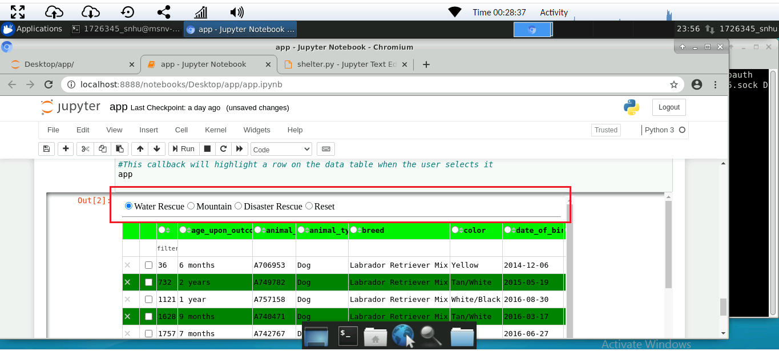

This is a screen shot of the geocharts as a table also can be interacted with

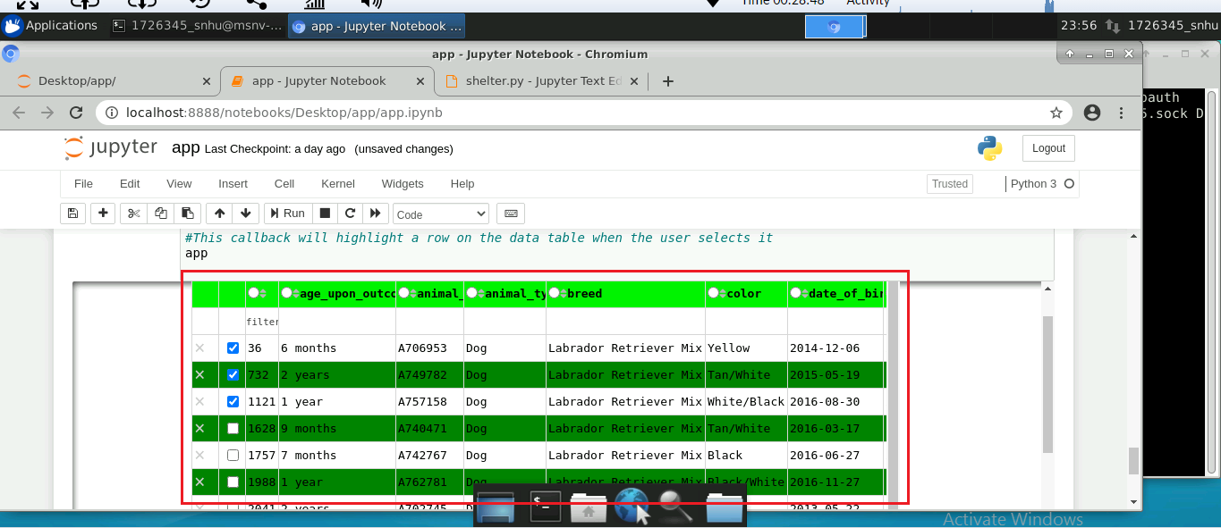

## Contact

Your name: Sarah Sandstrom